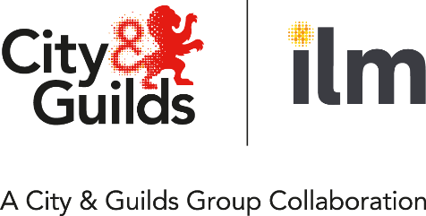
Application for fast track qualification approval
Fast track approval is a streamlined approval process for existing centres. Typically, it is used when
- a qualification is replaced or updated.
- approval for an N/SVQ would automatically entitle the centre to offer the corresponding VRQ.
The qualification(s) listed below indicate those you may currently offer that would now entitle you to fast track approval for the new qualification(s) overleaf.
If you are unsure of your centre’s status regarding your eligibility for fast track approval, please contact the Quality Team. Once completed, please send this form to quality@cityandguilds.com
Centre name |  | Centre number
Address
Postcode
Quality Team
Name of contact
E-mail address |  | Telephone number
Please tick the boxes of the qualifications below you currently offer which will be replaced
Qualification number |  |  |  |  |  |  | Level | Title | Tick
8 | 4 | 2 | 0 | / | 0 | 1 | 5 | Level 5 Diploma for Leaders & Managers
Please tick the boxes of the qualifications below you would like to request fast track approval for
Qualification number |  |  |  |  |  |  | Level | Title | Tick
8 | 4 | 2 | 1 | / | 3 | 1 | 5 | Level 5 Diploma for Operational Leaders and Managers
And (please select both)
8 | 4 | 2 | 1 | / | 3 | 3 | 5 | Level 5 Diploma for Operational Leaders and Managers

I confirm that this centre has previously offered the qualifications as detailed above. Where changes have taken place, a completed Centre Update form, plus CVs of Assessors/Internal Quality Assurers where appropriate, has been submitted.
I also confirm that all necessary resources for offering the new qualifications are currently in place.

By completing this form I confirm that we agree to the following actions:

- The qualification handbook will be shared with the entire delivery and assessment/IQA team.
- Learner journeys will be updated and be made available for the EQA to review at the next EQA activity.
- All scheme of works and lesson plans will be updated and be made available for the EQA to review at the next EQA activity.
- Training sessions will be delivered to update the delivery team on the new qualification and evidence of this training be available for the EQA to review at the next EQA activity.

I understand that, in order to process this application, City & Guilds may require further information possibly involving an external quality assurance activity, which may incur a fee.

Signature
Name
Date | (dd/mm/yyyy)
Please email this form to your City & Guilds Quality Team at Quality@cityandguilds.com or telephone Customer Services on 0192 4930 800.

