


Instruction to your Bank or Building Society to pay by Direct Debit
Please fill in the whole form using a ball pen and send it to:
Originators Identification Number
ILM
No. 1 Newlands Court
Attwood Road
Burntwood
Staffordshire
WS7 3GF

9 | 1 | 6 | 4 | 0 | 5

Trading Name and Payer/Customer Number ILM Reference Number (for office use only)

Name(s) of Account Holder(s) Instruction to your Bank/Building Society
Please pay the ILM Direct Debits from the account detailed in this instruction subject to the safeguards assured by the Direct Debit Guarantee.

I understand that this instruction may remain with the ILM and if so details will be passed electronically to my Bank/Building Society.

Bank/Building Society account number

Branch Sort Code

Name and full postal address of your Bank/Building Society Originators Identification Number
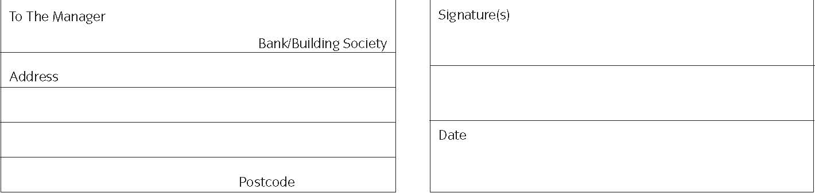
Banks and Building Societies may not accept Direct Debits for some types of account

-------------------------------------------------------------------------------------------------------------------------------------------------------------------
This guarantee should be detached and retained by the payer


The Direct Debit Guarantee
This Guarantee is offered by all banks and building societies that accept instructions to pay Direct Debits
• If there are any changes to the amount, date or frequency of your Direct Debit ILM will notify you 10 working days in advance of your account being debited or as otherwise agreed. If you request ILM to collect a payment, confirmation of the amount and date will be given to you at the time of the request
• If an error is made in the payment of your Direct Debit, by ILM or your bank or building society you are entitled to a full and immediate refund of the amount paid from your bank or building society
- If you receive a refund you are not entitled to, you must pay it back when ILM asks you to
• You can cancel a Direct Debit at any time by simply contacting your bank or building society. Written confirmation may be required. Please also notify us.

H:\Finance\ACCOUNTS\Direct Debit – ILM\Direct_Debit_Form.doc

